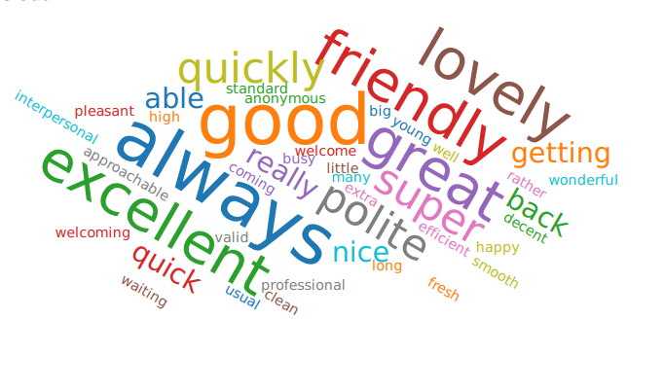
March 2021 – Patient feedback
- Prompt service. No waiting. Efficient professional staff.
- Service is always good they look after me very well..
- I was satisfied with my treatment
- Always excellent care which has continued throughout the pandemic.
- The lady on the desk was super polite I didn't catch her name a young lady.
- Very polite and very helpful
- Very welcome on arrival and nice staff
- Dr was helpful and understanding and took time to explain things.
- The nurse was super helpful
- Yes despite being busy the reception staff and nursing staff always give me a little extra time if I have questions. All the staff are approachable, and they all make time to smile.
- Because the staff are polite happy understanding and helpful.
- Excellent service from your staff and the nurse
- I felt that the proposed referral for specialist treatment was a good idea from the GP
- GP took his time and had a friendly manner. I have studied interpersonal relationships and communication skills and the basics make a big difference.
- Don't think I would have been able to talk to the Doctor as long in person as I did over the phone too
- Everyone pleasant and helpful
- My first time coming to the Rosegrove surgery I was treated very good and the surgery was so clean
- Good to be able to speak to a receptionist rather than an automated machine and great service the doctor getting back to you quickly and getting a quick diagnosis
- Quick and prompt response from my request for information
- Great staff
- Got through to reception quickly and she was really helpful. Phoned back with an appointment quickly . Seen and reassured with follow up appointment offered if required
- The lady was friendly, and I was in and out in no time.
- Doctor was lovely and helpful and the reception staff was lovely
- Very smooth process.
- Because the service was - 1. Very Good
- Excellent service
- The practice staff are always very friendly and the nurse I saw was lovely. They all do a wonderful job.
- Because I have always had excellent service from all the staff

